
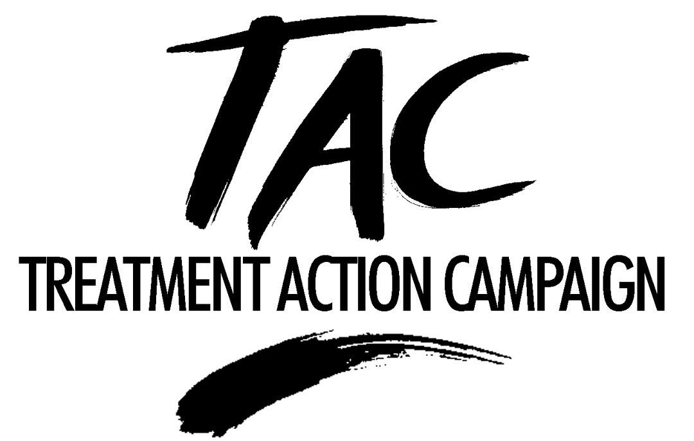

Joint submission

The Charter of the Public and Private Health Sectors of the Republic of South Africa (“the Charter”)

Drafted by:

Fatima Hassan
(021) 467-5628 (t)
(021) 461-2814 (f)
hassanf@law.wits.ac.za

Mark Heywood
(011) 717-8600 (t)
(011) 403-2341 (f)
heywoodm@law.wits.ac.za

Endorsed by:

Southern African Catholic Bishops' Conference AIDS Office
Ref: Sr Alison Munro, Director
(012) 323 6458 (t) 012 326 4309 (f)

National Council of Trade Unions (NACTU)
Ref: Chaka M A Leepo, National Coordinator OHS and HIV/AIDS Programmes
(011) 833 1040 (011) 833 1032 (f)

INTRODUCTION

The AIDS Law Project (ALP) and the Treatment Action Campaign (TAC) support the development of a Health Charter, and acknowledge the task team’s efforts to produce the present version of the draft Charter. However, we are concerned that the draft does not make clear the main purpose and objective of the Charter, particularly given its potential to put in place a powerful policy framework for overseeing and unifying health service delivery.

Regrettably, there are a number of serious flaws that require significant reconsideration and substantial redrafting. In addition, we are concerned that the draft Charter was developed in the absence of any significant consultation with key stakeholders, including civil society organisations and health worker trade unions in particular. Further, as a result of the imposition of very tight deadlines for the making of written submissions, public participation has been curtailed and, where permitted, very rushed. This undermines the Constitutional imperative of acting in a transparent, accountable and open manner.

PARTIES

Without a commonly agreed framework for transforming the health sector, the Charter will not result in any meaningful change. The Charter should therefore be seen as an opportunity to bind the private sector to a framework agreement that is premised on collaboration and shared responsibility for achieving national health objectives.

With this in mind, we therefore propose that the parties to the Charter must include government, the private sector, not-for-profit providers (including NGOs), health care workers in both public and private sectors, health worker trade unions, and most importantly, organisations of people who use the country’s health services (“consumers”).

All these parties should agree to combating activities and trends in the public and private sectors that currently limit access to health care, as well as endorsing measures to compel such transformation, such as the promulgation of relevant regulations issued in terms of the National Health Act, 61 of 2003 (“the NHA”).

APPLICABLE LAWS

Although the draft Charter refers to the government’s Constitutional obligations (read in conjunction with the NHA), it does not make it clear enough that these laws:
- Have not been able to alter the trend towards greater inequity in access to health care in the last ten years. As the draft says: “Access to health services of unacceptable quality is not access.” (2.3.1)

- Already place positive duties on government to take “reasonable measures” to ensure that “everyone” has access to health care services. This includes a Constitutional duty to regulate the private health sector and take measures to ensure that, as a result of its conduct, the private health sector does not directly or indirectly limit the rights of others to access health care services.

PREMISE OF OUR SUBMISSION

Our submission is premised on the following:

- The public health system is in a deep crisis and is collapsing under the weight of an increasing burden of disease (in particular HIV/AIDS), mismanagement, under-investment and a dire shortage of human resources; and

- Private health care is becoming even more inefficient, expensive and exclusive.

Within this context, our vision of a unified health service is one where:
- Place of residence, health status, economic status and the ability to pay do not determine whether a person has access to the essential health services that he or she needs.
- The provision of health care services can take the form of a mix of public and private sector (including not-for-profit) delivery.
- Access to an essential set of quality health services does not depend in any way on which sector provides the service.
- Individual contributions towards the costs of health care services, whether in the form of user fees, medical scheme contributions or any other form, is affordable and income-related.
- Everyone gets access to quality health services, whether in the private or public sector. Only those who are in a position to contribute directly towards their own health care costs would be required to do so.

In other words, a unified health service would not require people to pay anything towards the costs of their health care if they are not financially able to do so.

OBJECTIVE OF THE CHARTER

In light of government’s Constitutional obligations, it is both reasonable and necessary to transform South Africa’s health services.

Therefore, we believe that the objective of the Charter should be to:

- Unify public and private health providers as signatories to a framework agreement (the Charter);

- Take measures to achieve the government’s major health objectives, in particular universal access to a package of primary health care;

- Set time-frames for achieving key transformation goals; and

- Remedy imbalances in the South African health system that continue to adversely affect the right of access to health care services.

It can do so by:

- Addressing transformation in a manner that “ensures equal access to equal care for equal need in a situation in which resources are efficiently utilised in a fair manner” (2.1.1); and

- Setting out the responsibilities and obligations (including measurable targets) of all stakeholders in transforming and unifying the health sector into one that is equitable, accessible and affordable.

In our view, the Charter should be the vehicle for achieving some of the most difficult objectives contained in the NHA, in particular, defining agreements that aim to:

- Provide “in an equitable manner the population of the Republic with the best possible health services that available resources can provide” (section 2(a)(ii) of the NHA);

- Ensure the “provision of such essential services, which must at least include primary health care services, to the population of the Republic” (section 3(d) of the NHA). In so doing, the Charter should not just commit to developing a “minimum defined basic package”, but should also detail this package; and

- Find solutions to the human resource crisis, including making detailed plans to ensure that:

- Essential health personnel are available in rural areas;

- A health worker training plan is agreed with the Department of Education;

- Private health practitioners are drawn into providing care for public sector patients, particularly in areas where public health facilities are remote or nonexistent; and

- Mechanisms for attracting private general practitioners (GPs), pharmacists and independent practitioners into the public sector – even as sessional appointments – are considered.

MINIMUM CONTENT

In our view, the Charter should at the very least:

- Set concrete targets and plans – including time frames – to bring about greater access to quality services in both sectors, including introducing measures to regulate spiralling private sector costs.

- Set a time frame for the implementation of universal coverage, with government taking charge of implementation. Significantly, government is considering introducing a system of Social Health Insurance (SHI) (albeit controversially) and National Health Insurance (NHI) as part of a long-term policy plan of transforming the health system. However the Charter is silent about what it sees as the role of SHI and NHI, as well as the recently approved Risk Equalisation Fund (REF), in increasing access and equity. In this respect, we would like to place on record that the ALP and TAC does not support the implementation of SHI in the manner that is currently being proposed by the Department. As such, we will engage with the Department and/or the relevant parliamentary committees when the process is opened up to public participation.

- Recommit to increasing government funding for health so that the current level of 12.6% (non-interest expenditure) of GDP meets or exceeds the target of 15% agreed to at Abuja in 2001. The Charter refers to the funding imbalance (currently a public: private ratio of 38: 62). We suggest that the Charter set targets to rectify this – for example, “by 2010 the ratio of private to public funding should be 50/50”.

- Aim to manage and oversee resources spent in the public sector by committing users of health care to participate fully in the structures proposed by the NHA, including clinic committees, hospital boards and district health forums.

- Set a framework for monitoring the allocation of health resources, with a clear focus on provincial budgets, as well as monitoring provinces’ ability to spend health budgets. This is important given that municipal health services are now defined particularly narrowly in local government legislation. In other words, local government revenue can now only be used for a limited number of health care services, placing an increasing burden on provincial health services.

- Propose to end/phase out the subsidising of private health care. Also, address overspending in the private sector.

- Ensure that the private sector agrees to an increase in effective state regulation of the spiralling costs of medicines, laboratory fees, hospital fees and medical scheme non-health expenditure (administration fees). Government and the private sector should also commit to combating anti-competitive conduct including collusion and price fixing in sectors such as hospital care and pathology.

- The Charter proposes a Human Capital Programme “that fairly plans for and meets the human resources requirements of South Africa over the next few years” (3.2.4, page 29). It should:

    - Try to identify measures to end the untenable situation where there is a surplus of health professionals in the private sector matched to a scarcity in the public sector.

    - Endorse a human resource (HR) plan that adheres to internationally acceptable health care worker/patient ratios, and then sets out the steps that must be taken to reach these ratios.

    - Identify and endorse mechanisms for the effective referral between health care workers and health care services and other essential health related services such as social work, education, agriculture and transport, especially in respect of children and young people.

    - Set targets and timeframes for developing such a programme. In the present draft it is unclear how these targets will be developed, given that it only proposes a mechanism for monitoring implementation. This is important given that draft Strategic Framework for Human Resources (released recently) also omits to set benchmarks, or to identify HR needs with any precision.

In finalising the Charter the Department should:

- Work with organizations of health care providers (such as the South African Nursing Council (SANC), the South African Medical Association (SAMA) and health worker trade unions) to identify the human resource requirements for the provision of good quality primary health care services at district level, and specify these needs. These needs can then be matched against existing capacity.

- Attempt to quantify the human resource (HR) requirements needed to implement the NHA, including those sections dealing with the rights of users, which impose an additional burden on health workers.

- Attempt to identify and quantify the HR requirements and coordination mechanisms with the Departments of Education and Social Development needed to implement supportive services and policies to the NHA, including those sections dealing with the rights of users, taking into account the particular needs of groups such as children, adolescents, women, the elderly and people with disabilities.

- Work with the Department of Education and tertiary institutions to identify our needs for the reproduction of specialised skills in medicine.

- Aside from general HR targets, set targets for attracting and training certain categories of people (by virtue of the definition of broad based black empowerment) to work as health care practitioners in order to achieve “equitable representation in all occupational categories and levels in the workforce”.

Broad-Based Black Economic Empowerment (BB BEE)

While we support government’s broad-based BEE objectives, we do not believe that there is a necessary correlation between simply transforming patterns of ownership in the private health sector and improving access to health care services. In our view, the draft Charter places a disproportionate amount of emphasis on BEE. It does so by wrongly equating transfer of ownership with access and equity.

Instead, the Charter should be primarily concerned with the transformation of the health system itself, and not simply the transformation of ownership of private health care resources. We believe that the draft Charter wrongly focuses on changes in ownership and in so doing offers insufficient attention to structural changes that must result from BEE (for example, new investment and jobs that lead to an increase in competition and greater access to affordable services).

For us, changing patterns of ownership will not in and of itself contribute to meeting the objectives of equity, access and affordability. Instead, in addition to changes in ownership, we see real BEE in the health sector being achieved through a public-private skills development programme and the finalisation of the HR plan with a proper system of career-pathing for health workers.

But even before BEE is carried forward, we propose that the Charter set out minimum safeguards and quality control mechanisms to monitor the quality of services in both sectors, including public-private partnerships. Failure to ensure effective oversight will result in government depriving itself of the ability to ensure that private companies are meeting their contractual obligations under service-level agreements.

If private companies are to become involved in public-sector health care provision, they must:

- Visibly improve service delivery within a contracted period;

- Provide capacity training and skills development as part of any service-level agreement. This would enable public sector employees to gain some of the skills that they need, which in turn would enable the department to improve its ability to provide an effective public health service;

Parties to the Charter should therefore agree on “access targets”, including improving access for public sector patients that use private services and vice-versa. Further, a concrete plan to undo the inequitable allocation of public and private resources should be specified in the Charter.

FURTHER NEGOTIATION AT NEDLAC

We believe that the Charter should be referred to the NEDLAC Development Chamber for further discussion and finalisation. Such a process will include all stakeholders (business, government, labour and community), allow for a more structured and open system of participation, and make it possible to include other relevant government departments. An agreement at NEDLAC will give the final Charter greater weight and authority.

CONCLUSION

In a letter to the Minister of Health dated 12 August 2005, co-signed by a range of important stakeholders in the health sector, we requested that the process of finalising the Charter be re-opened to allow for further discussion and negotiation. Such a process should not delay the finalisation of the Charter, and would most likely result in a finalised Charter that is coherent and concrete, setting out targets, timeframes and a vision of health care that benefits poor people.

This, we believe, would inspire and restore confidence in providers of health care, with the knowledge that there is an agreed plan to remedy the current crisis. Equally importantly, it would be a Charter against which users of health care (in particular the poor) would be able to measure our country’s progress towards developing and implementing a health system in which everyone is guaranteed and has access to all essential health care services.

Cape Town and Johannesburg

15 August 2005

Some of the cost drivers in the private sector which make health care increasingly unaffordable and which the Charter should pledge to stamp out are over-servicing, rising administrative costs, exorbitant hospital fees, medicine prices and pathologists’ fees.
Our policy and legal framework already: - Regards health as a human right; - Requires equity in resource allocation; - Introduces certain measures to regulate the availability and cost of health care services and the prices of medicines; - Provides the framework for a health care system that is premised on promoting primary health care; - Regulates medical schemes, outlaws risk rating and prescribes a minimum package of benefits for private users; - Regulates the conduct of medical professionals through various professional regulatory and statutory bodies; - Outlaws unfair discrimination on enumerated and other unlisted grounds in the provision of services; and - Outlaws price setting through outlawing of private tariffs.
The annual average increase in expenditure amongst medical schemes in the private sector is between 20-30 %. It is clearly not able to contain costs. The funded and unfunded private sector is expensive, unaffordable and inefficient.
Universal coverage would: - Guarantee universal access (includes the formal and informal sector and includes the unemployed); - Use a single funding mechanism and make it easier to administer; - Encourage social solidarity and cross subsidization not only amongst the well off but between poor and rich as well; - Equalize the allocation of resources across sectors; - Achieve optimal quality by actively purchasing good services; and - Make creative use of public, private and not for profit services.
The Constitution recognises that good health and access to health care services are essential for people to exercise their rights to dignity and life. In particular, the Constitution provides that the state must ensure that all people are able to access health care services and other basic socio-economic rights, and that it: “must take reasonable legislative and other measures, within its available resources, to achieve the progressive realisation of each of these rights.”
This is because South Africa is one of the world’s most unequal societies, whether looked at on the basis of race, class, economic status or place of residence. Poor health, which directly results from poor socio-economic conditions including lack of proper sanitation, malnutrition, poor living and working conditions as well as limited access to essential health care services, deepens these existing divisions and inequalities.
In this regard, the contents of the Charter should include in principle agreements between stakeholders on issues that the department of health will give effect to in regulations promulgated in terms of the NHA.
The figure is 11% with interest expenditure.
In the private sector spiralling costs, lack of access, inequitable funding, inefficient spending of resources, and poor or sub standard quality of care are important areas that require better state regulation.
Increased medical scheme contributions and co-payments, as well as reductions in cover that result in increased out-of-pocket spending, contribute to an inefficient overspending of health care. Removing tax subsidies to middle and high income earners, reducing medical scheme contributions (which are generally not income-related) and limiting out-of-pocket (OOP) expenditure are necessary to control over funding and over spending in the private sector. Without a plan to address funding, the private sector will continue to benefit disproportionately from state and private funding.
While the percentage increase in administrative fees over time is worrying, this has come off a low base and is already being targeted by the Council for Medical Schemes. It is interesting to note that the sudden surge in non-health expenditure roughly coincides with the introduction of the Medical Schemes Act 131 of 1998.
At present, there is no effective competition amongst the three main hospital groups. This results in unaffordable and excessive hospital fees in the private sector. Given that private hospital groups are for profit, here is also an urban/rural and interprovincial skew in the setting up of new private hospitals. The Charter’s proposals in respect of black economic empowerment (BEE) do not appear likely to alter or halt the cartel-like activities of the hospital groups. In other words, we do not believe that BEE will be effective in dismantling existing monopolies.
For example, nursing, hematology, pharmacy, community outreach, pathologists.
The HR race and gender composition targets included in the Charter appear slightly out of date. For example, the transformation target for workplaces is 60% black people and 50% women by 2010, rising to 70% black and 60% women by 2014. According to the Gauteng MEC for Health (in her 2005 budget speech), for example, the Gauteng health department already has black people comprising 81% of staff and women 77%. This already exceeds the 2014 targets as well as the 2010 targets. In such circumstances, there appears to be very little value in setting targets that have long since been achieved.
For example, Kgalema Motlanthe (2005) argues that current BEE process have primarily been about a simple transfer of economic power, and not about the active transformation of the economy.
In the Eastern Cape (EC), for example, it has been reported that the privatisation of certain health services has undermined service delivery in the province. For example, the Fleet Africa Service Level Agreement (SLA) contained no provision for emergency services. In this regard, the Auditor-General reported to Parliament that the EC Provincial Department of Health failed to monitor Fleet Africa properly. The EC has subsequently recognised that the contract led to an increase in transport costs and that service levels have not improved. Despite this, the Fleet Africa SLA has still not been renegotiated, placing users of the public health system at increased risk of harm.
Service-level agreements entered into must set out in detail the firm expectations of the department, as well as detailing the commitments made to it by the private company concerned.

